SELECT * FROM obat JOIN detail_obat ON obat.id = detail_obat.obat_id ORDER BY nama_obat ASC;

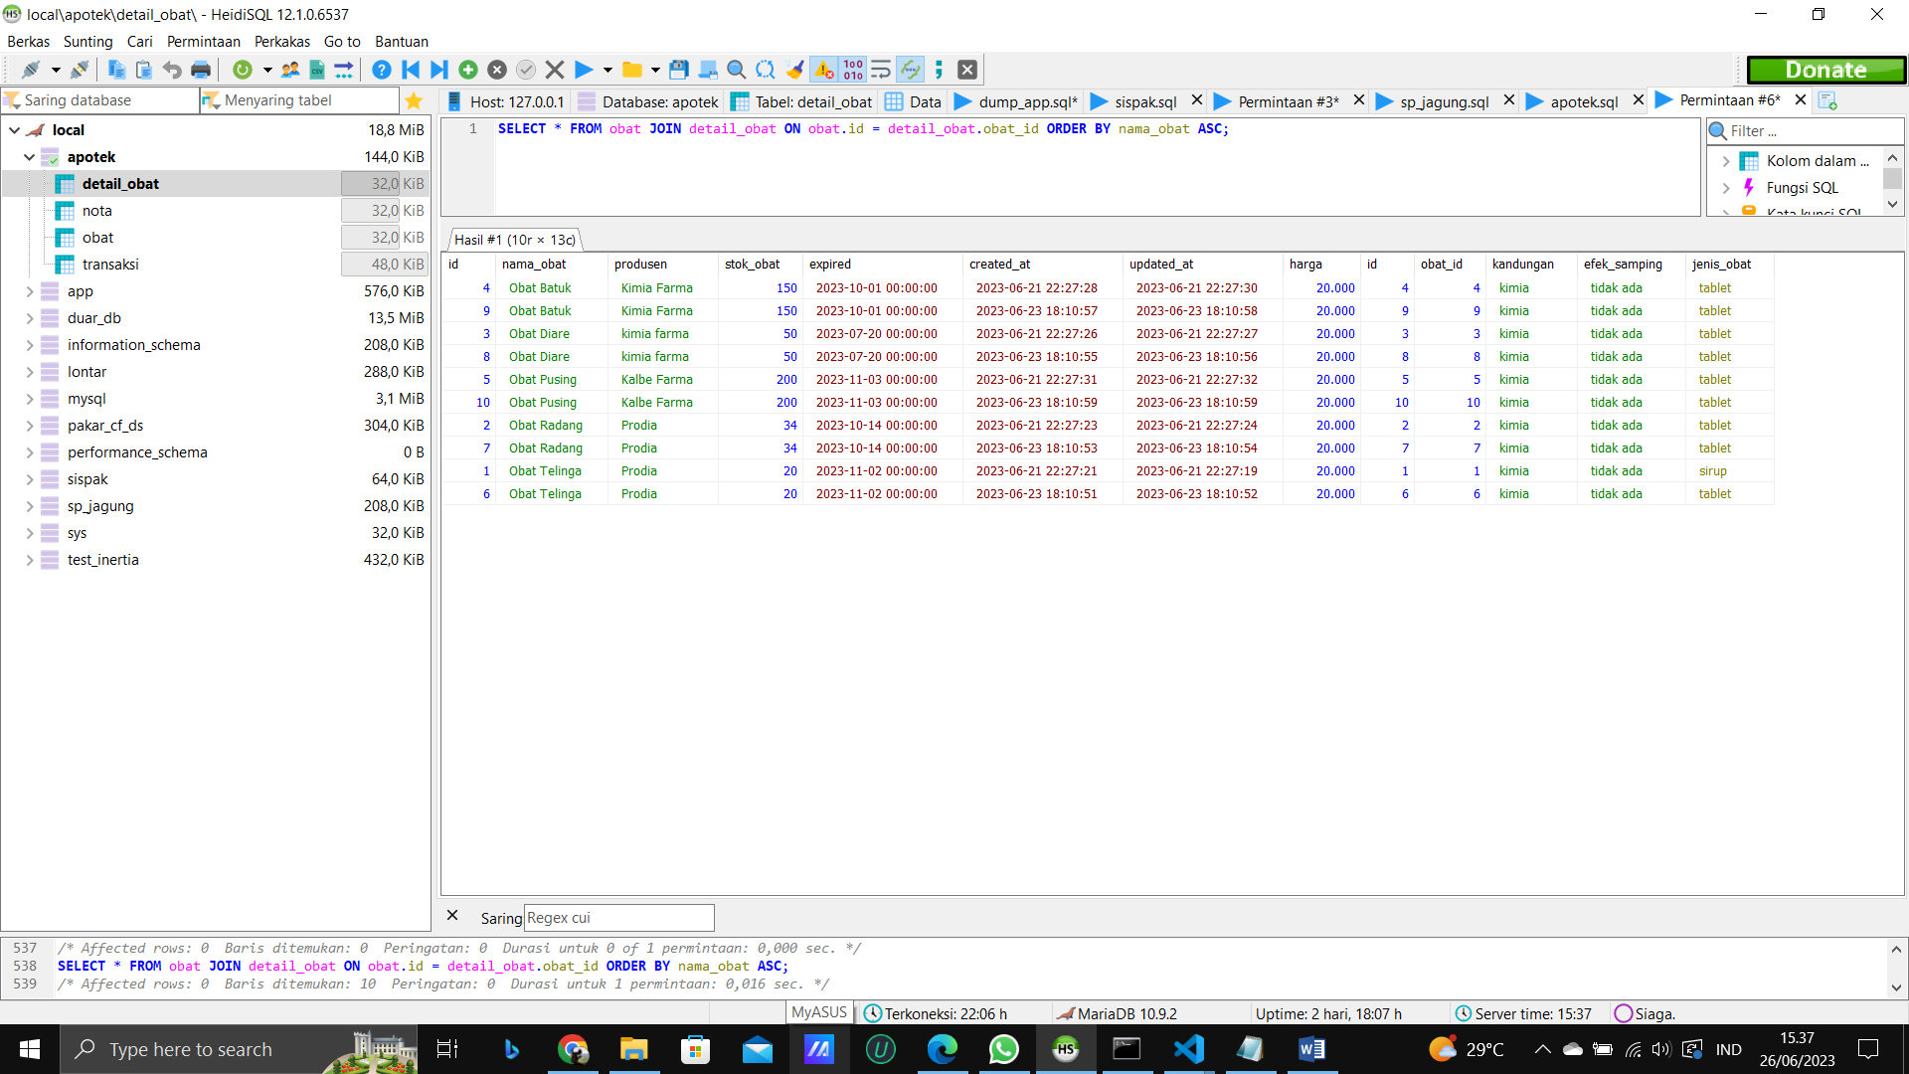

SELECT * FROM obat JOIN detail_obat ON obat.id = detail_obat.obat_id WHERE stok_obat > 100 ORDER BY nama_obat ASC;

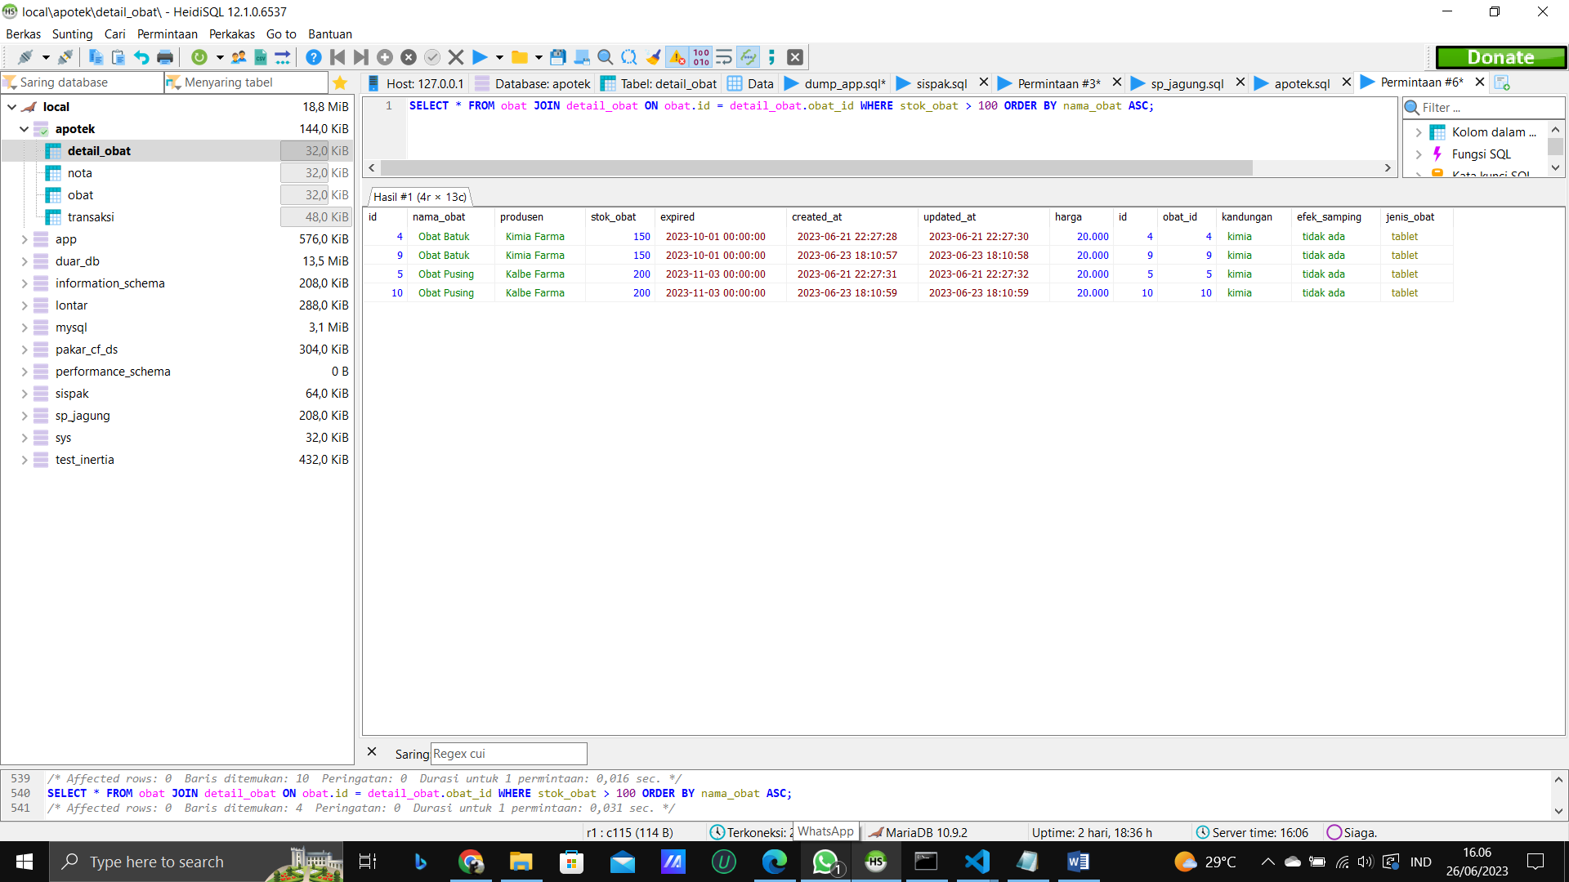

SELECT obat.id, nama_obat, COUNT(transaksi.id) as jumlah_transaksi FROM obat JOIN transaksi ON obat.id = transaksi.id_obat GROUP BY obat.id ORDER BY nama_obat ASC;

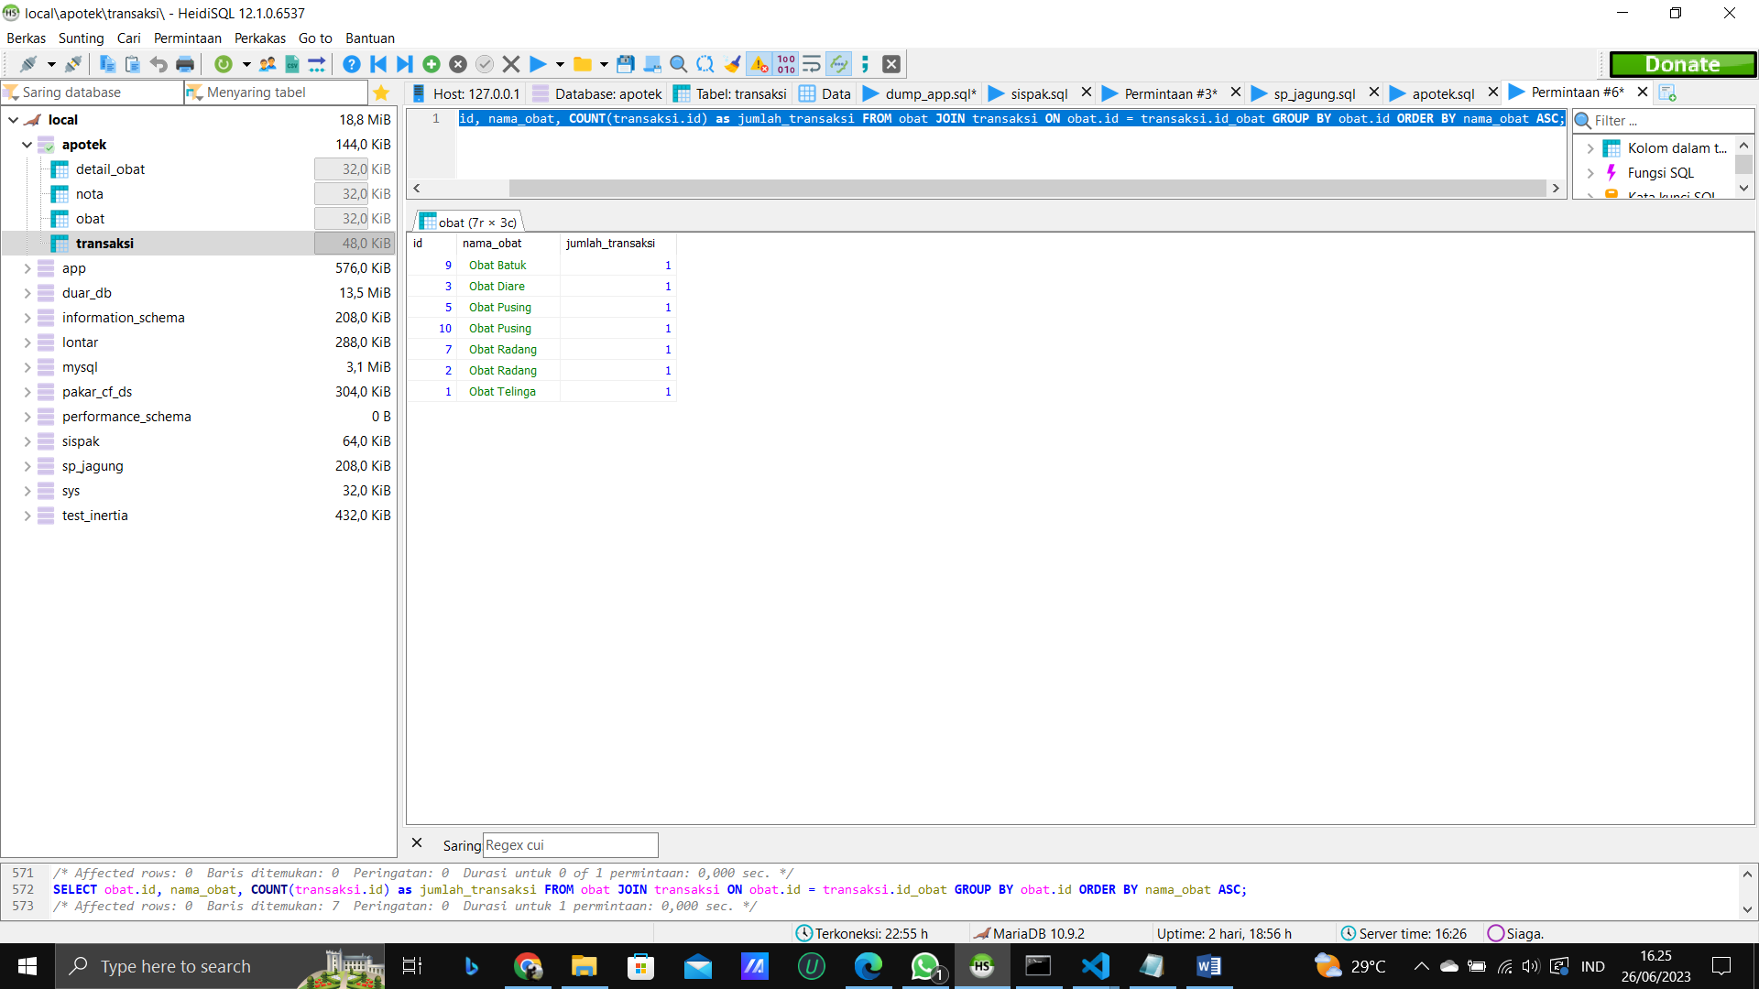

SELECT nama_obat, produsen, stok_obat, COUNT(transaksi.id) jumlah_transaksi FROM obat LEFT JOIN transaksi ON obat.id = transaksi.id_obat GROUP BY obat.id ORDER BY nama_obat ASC;

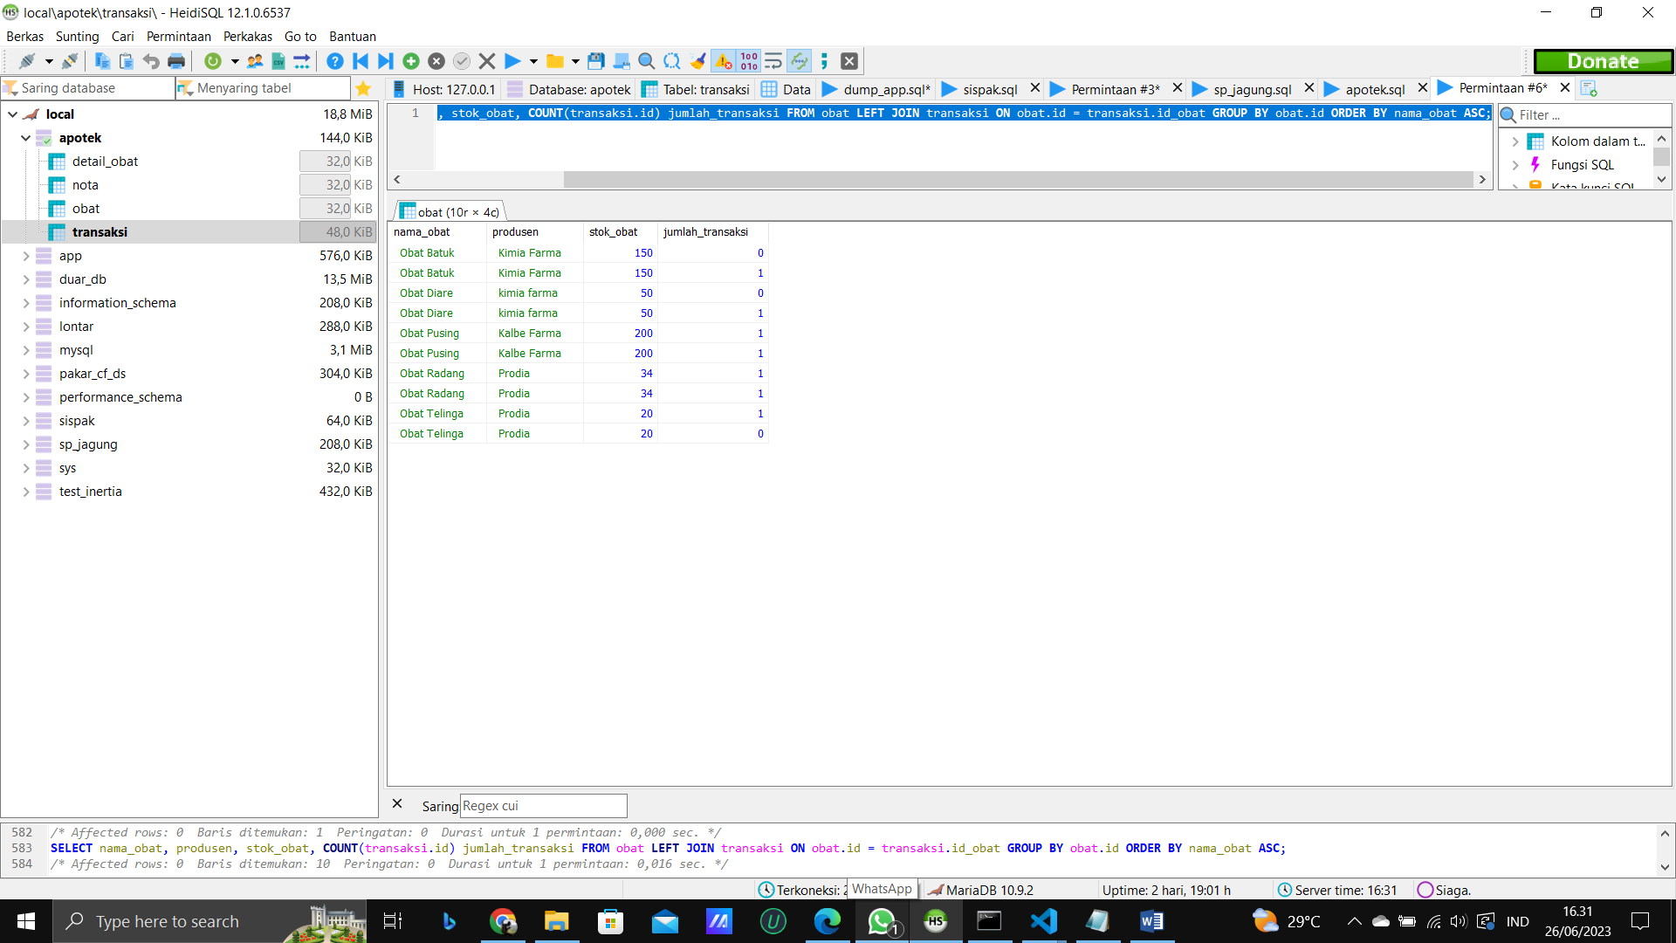

SELECT * FROM transaksi RIGHT JOIN nota ON transaksi.kode_nota = nota.kode_nota WHERE total_kembalian > 0;

